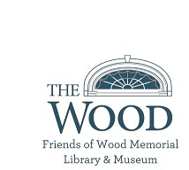
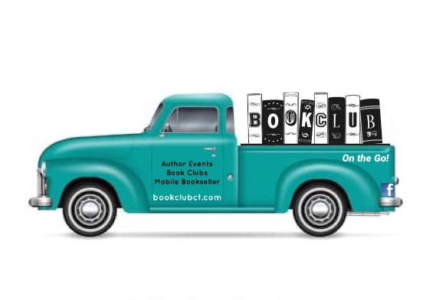

2024 Reading Challenge

Title 1-5 stars     

Read a book by a BIPOC author* □___________________________ rating ___

Read a book translated into English □___________________________ rating ___

Read a book with a person on the cover □___________________________ rating ___

Read a book adapted for tv/film/stage □___________________________ rating ___

Read an award winner (Booker, PEN, Pulitzer, etc.) □___________________________ rating ___

Read a book with a real location in the title □____________________________rating ___

Read non-fiction book □___________________________ rating ___

Read a book with a character name in the title □___________________________ rating ___

Read a book w/historical event you’re unfamiliar with □___________________________ rating ___

Read a banned book* □___________________________ rating ___

Read a book about books, or set in a library/bookstore □___________________________ rating ___

Read a book published in 2023/2024 □___________________________ rating ___

Name: ___________________________ Email: ______________________________

To be entered to WIN a $25 gift certificate from Book Club on the Go and
a $25 gift certificate from Friends of Wood Memorial Library & Museum
complete & email this form to shop@bookclubct.com by Dec. 31, 2024.

Download the challenge at www.bookclubct.com or www.woodmemoriallibrary.org
Want to share your progress? Tag @bookclubct on Facebook/Instagram

*an author who is Black, Indigenous, or a Person of Color
* www.ala.org/advocacy/bbooks

